# Workshop 12 Lab 1

In this activity, we are going to implement a few simple Vertex and Fragment Shader. Create a new Unity3D project and perform the following tasks.

1. Install Core RP and Universal RP

From Window->Package Manager->Packages: Unity Registry-> Install Core RP and Universal RP

Follow the instruction in the link to configure UPR into an existing Project

https://docs.unity3d.com/Packages/com.unity.render-pipelines.universal@10.8/manual/InstallURPIntoAProject.html

1. First Shader

Create a Shader folder.

Create a standard Surface Shader in Shader folder and name it as TestShader.

Create->Shader->Standard Surface Shader

Replace the content with the FirstShader code.

Create a new Material, name it as TestMaterial.

Create a new Sphere and Capsule object in the scene.

Attached the Material to the 2 objects. (Drag and drop the TestMaterial into Sphere and Capsule Component).

Change the Material shader.

Change the base colour in the shader.

|  |  |
| --- | --- |
|  |  |

1. Vertex Position Shader

Create a new Shader and name it VertexPositionShader.

Copy the FirstShader into VertexPositionShader.

Modify the following.

Change the name

Change the vertex shader.

Change the Material shader.

Include _Time in the vertex shader.

The effect can only be seen when the scene is executed.

1. Fragment Colour Shader

Create a new Shader and name FragColourShader.

Copy the FirstShader into FragColourShader.

Modify the following.

Change the name.

Always return a cyan in the fragment shader

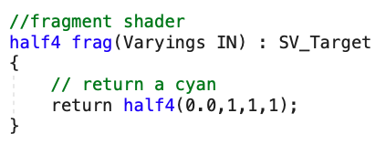

Change the Material shader.

1. Fragment Blinking Shader

Create a new Shader and name FragBlinkingShader.

Copy the FirstShader into FragBlinkingShader.

Modify the following.

Change the name.

Include _Frequency in Properties

Include _Frequency in CBUFFER

Modify the fragment shader

Change the Material shader.

Run the scene and observe that the colour intensity is changing with time.

1. Texture Shader

Create a new Shader and name TextureShader.

Copy the FirstShader into TextureShader.

Modify the following.

Change the name.

Add _Scale in Properties

Add in positions in Varyings

Change to _Scale in CBUFFER.

Include positions in vertex shader.

Modify the fragment shader

Make the scale dependent on sine of time for animation.

End.